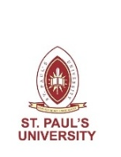 | 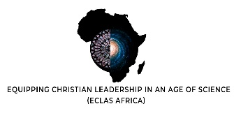 | 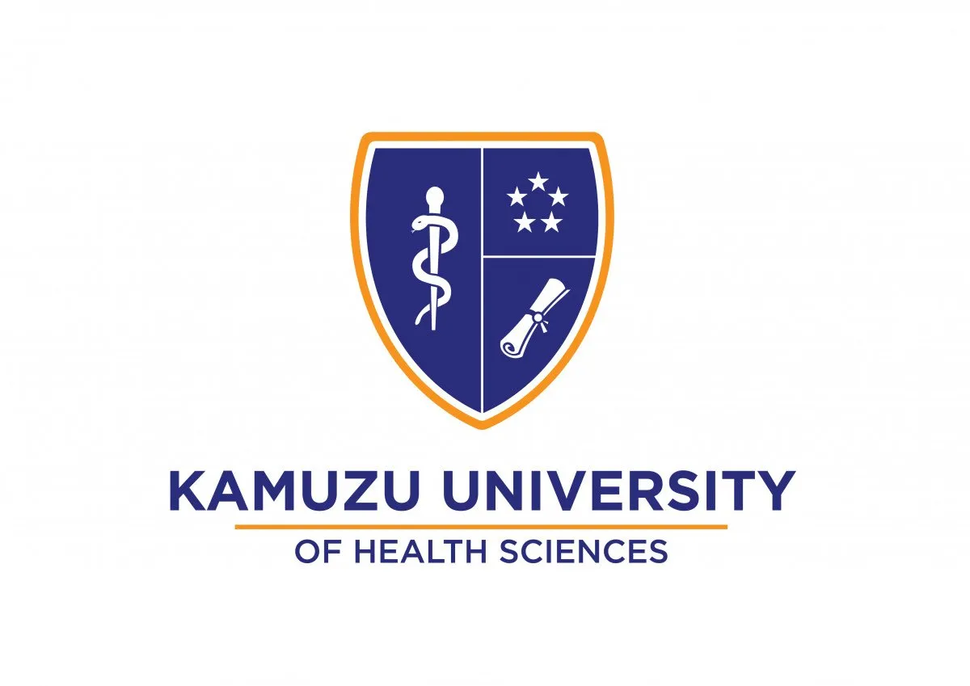
ST. PAUL'S UNIVERSITY, KENYA
in collaboration with
KAMUZU UNIVERSITY OF HEALTH SCIENCES, MALAWI (ACEPHEM)
PRESENTS
ECLAS AFRICA HUB
EAST, CENTRAL AND SOUTHERN AFRICA (ECSA)
Conference for Senior Church Leaders and Scientists
CALL FOR PAPERS

“Is there no medicine in Gilead? Is there no physician there? Why is there no healing for the wounds of my people?” — Jeremiah 8:22

CONFERENCE THEME
“The Intersection of Science, Culture, Religion and Theology in Provision of Health Care”

CONFERENCE DATES  1st – 3rd September 2026 | HOSTED BY  Kamuzu University of Health Sciences, Malawi Through the  Africa Centre of Excellence in Public Health and Herbal Medicine (ACEPHEM)

BACKGROUND
The contemporary world is characterized by a myriad of research paradigms, protocols and innovations across different vocational, academic and professional disciplines, all of which are aimed at promoting human life. Unfortunately, there exists a persistent tension between experts in the hard sciences and their counterparts in the social sciences and humanities — a conflict that has led to wastage of knowledge and innovation. In the health sector, for example, innovations are sometimes questioned on religious or cultural grounds, while scientists have often dismissed ideas from indigenous knowledge for lack of empirical validation.

How can the gap between science and other disciplines be bridged for the benefit of humankind? Equipping Christian Leadership in an Age of Science (ECLAS) aims to bridge the gap between science, faith, and culture by facilitating a mutually beneficial conversation. The guiding question is: ‘How does context give challenges and opportunities for equipping Christian Leadership in an Age of Science?’

One of the strategies that ECLAS uses to answer this question is by convening conferences for top scientists, scholars, theologians, and religious leaders to engage in a manner that creates a synergy of ideas and a multidisciplinary approach to societal problems. Against this background, ECLAS Africa Hub, working in collaboration with Kamuzu University of Health Sciences, Malawi, has organized an interdisciplinary conference to take place from 1st to 3rd September 2026.

ECLAS AFRICA HUB CONFERENCE 2026
ECLAS AFRICA OBJECTIVES
- To bridge the gap between science, faith, culture, and indigenous knowledge for the benefit of humanity.
- To provide a forum for scientists, theologians, scholars, researchers, and practitioners to exchange knowledge and ideas.
- To promote critical interdisciplinary research and the application of ethical, scientific, and theological principles.
- To improve health care delivery by integrating scientific innovation with cultural and religious wisdom.
- To equip Christian leaders with scientific literacy and scientific communities with theological and ethical frameworks.
- To foster partnerships, mentorship, and joint research and practice across disciplinary and geographic borders.

THE 2026 CONFERENCE HOST
The 2026 ECLAS Africa Hub conference will be hosted by the Kamuzu University of Health Sciences (KUHeS), Malawi, in partnership with St. Paul’s University, Kenya, from 1st to 3rd September 2026. Malawi offers a rich context for exploring the intersection of indigenous healing traditions, Christian faith, and modern biomedicine — making it an ideal location for this interdisciplinary gathering.

Kamuzu University of Health Sciences (KUHeS) is a comprehensive health and applied Sciences higher learning public institution. Established in 2019 through the merging of Kamuzu College of Nursing (est. 1965) and the College of Medicine (est. 1991), KUHeS is committed to providing top-quality education and training health professionals — including nurses, midwives, medical doctors, pharmacists, physiotherapists, nutritionists, and biomedical scientists — at both undergraduate and postgraduate levels.

St. Paul’s University, Kenya, brings to this collaboration its long-standing tradition of holistic, Christ-centred education and its growing expertise in interdisciplinary research at the intersection of faith, science, and society. Together, the two institutions are committed to producing graduates who are not only professionally competent but also deeply grounded in ethical, moral, and spiritual principles.

We anticipate that the conference will bring together scientists, senior church leaders, theologians, scholars, researchers, students, and health professionals from East Africa, across Africa, and beyond.

CONTEXT OF THE CONFERENCE
Amid growing health challenges and expanding intersections between science, religion, and culture, the conference addresses urgent questions facing African societies: How is artificial intelligence reshaping medicine and ethics? How do reproductive technologies interact with faith and tradition? How can indigenous healing knowledge complement modern biomedicine? And how should communities adapt to climate change’s growing impact on food and health security?

The conference engages issues that are locally rooted yet globally connected, including bioethics, health technology, indigenous knowledge systems, climate adaptation, and food security. Through plenary sessions, workshops, paper presentations, and panel discussions, participants will exchange knowledge and co-develop practical responses to real-world health and social challenges.

ECLAS AFRICA HUB CONFERENCE 2026
CONFERENCE THEME
The 2026 conference theme: “The Intersection of Science, Culture, Religion and Theology in Provision of Health Care” highlights the urgent need for interdisciplinary dialogue between scientists, theologians, health professionals, and cultural custodians to address Africa’s most pressing health challenges in a holistic way.

THE OBJECTIVES OF THE 2026 CONFERENCE
The 2026 ECLAS Africa Hub Conference aims to:
- Examine the impact of AI and emerging technologies on medicine, healthcare, ethics, and community health communication in Africa and their intersection with faith.
- Showcase African-led innovations at the intersection of biomedicine, indigenous knowledge, faith, and culture.
- Address key health challenges affecting African societies and communities, including those shaped by religion, culture, and development.
- Generate actionable outcomes for health policy, education, professional practice, and community development.
- Explore how faith and indigenous worldviews can enrich scientific research, bioethical deliberation, and healthcare delivery.
- Foster a mutually beneficial conversation between Christian leadership and the scientific community for the common good.

EXPECTED OUTPUTS
- Analytical Papers: Peer-reviewed papers will explore the conference theme and will be compiled into conference proceedings. High-quality papers will be selected for special publication in an indexed journal.
- Presentations: Keynote speeches, panels, workshops, and research presentations will spark interdisciplinary debate and knowledge exchange.
- Conference Report: A comprehensive report will summarize key discussions, findings, and recommendations, providing a roadmap for future research, policy, and collaboration.

EXPECTED OUTCOMES
- Strengthened Networks: New partnerships among scientists, theologians, church leaders, practitioners, and policymakers.
- Enhanced Scholarship: Greater visibility of African interdisciplinary research in health, science, and theology.
- Capacity Development: Learning and skill-building opportunities for participants, especially emerging researchers and church leaders.
- Policy & Practice Insights: Actionable recommendations for ethical, inclusive, and faith-informed healthcare strategies.
- Fostering Innovation: Inspiration for forward-looking ideas at the intersection of science, faith, and culture.

ECLAS AFRICA HUB CONFERENCE 2026
CONFERENCE SUB-THEMES

A | Creation, Artificial Intelligence, and Transhumanism  1. Artificial intelligence, automation, and the future of healthcare in Africa  2. Biblical theology and the philosophy of transhumanism  3. Digital governance, data protection, and ethical AI in medicine  4. Biotechnology, cybernetics, and the nature of humanity  5. AI-assisted diagnostics and the ethics of human enhancement

B | Faith, Religion and Reproductive Health Technologies  1. Religious responses to IVF, surrogacy, contraception, and genetic screening  2. Faith communities and bioethical decision-making in reproductive health  3. The role of religious leaders in shaping reproductive health policy  4. Science and faith in guiding responsible reproductive health decisions  5. Cultural and theological perspectives on the beginning of life

C | Indigenous Knowledge and the Management of Diseases  1. Medicinal plants, traditional healing, and community-based health management  2. Integration of indigenous practices into national health systems  3. Effectiveness of herbal remedies and traditional healers’ roles  4. Indigenous knowledge in addressing infectious diseases and chronic conditions  5. Bridging traditional medicine and modern biomedical approaches

D | Climate Change Adaptation and Food Security  1. Climate-resilient crops, sustainable farming, and agro-ecological innovations  2. Impacts of climate change on food availability, access, and nutritional quality  3. Water conservation methods and food security in vulnerable communities  4. Local knowledge, government policy, and scientific research for food security  5. Faith community responses to climate change and hunger

ABSTRACT SUBMISSION GUIDELINES

- Abstracts should be no more than 500 words and include the title, author(s), affiliation, and contact information.
- Clearly indicate the chosen conference sub-theme (A, B, C, or D).
- Include a brief biography of 50 words and contact information.
- Submissions should be sent to: eclas@spu.ac.ke on or before 20th June 2026.
- Authors of accepted abstracts will be notified and invited to submit full papers.

IMPORTANT DATES

1st July 2026  Abstract Submission Deadline | 2nd July 2026  Notification of Acceptance | 5th August 2026  Full Paper(s) Submission | 1st – 3rd September 2026  Conference Dates

KEYNOTE SPEAKERS & PANEL DISCUSSIONS

We are thrilled to host renowned scientists, theologians, and health leaders who will share insights on the intersection of science, culture, religion, and theology in the provision of health care. Their talks will inspire, challenge, and ignite interdisciplinary conversation across disciplines and borders.

We also invite experts to propose panel discussions on cutting-edge topics at the interface of faith, science, and health. Panels will foster dynamic, interactive dialogue and deliver actionable ideas for participants.

CONFERENCE REGISTRATION FEE DETAILS

CATEGORY | FEE | NOTES
Delegates / Professionals | USD 100 | Full registration including conference materials
Please note the following in relation to the above fees:
- Payment details including bank account information will be communicated upon acceptance of abstract submission.
- Fees cover conference registration, materials, meals during the conference, and a certificate of participation.
- Limited funding support will be provided.

CONFERENCE REGISTRATION ACCOUNT DETAILS
Acc Name: St. Paul’s University  Bank: National Bank of Kenya  Branch: St. Paul’s University Branch  A/C No: 01021091200100  Swift Code: BKEKENXXXX | Name of Bank: First Merchant Bank  Name of Account: College of Medicine ACE II Project  Account Number –FCDA (US$): 0006708000177  Account Number – MWK: 0006707000569  Branch: Umoyo Branch  Swift Code: FMERMWMW

ECLAS AFRICA HUB CONFERENCE 2026
ECLAS MEMBERSHIP & PARTICIPATION BENEFITS
- Opportunities for increased academic and professional networks across scientific and theological disciplines.
- Accreditation to an international interdisciplinary professional network.
- Eligibility to contribute to the ECLAS Africa Hub Executive and Planning Committees.
- Eligibility to propose and host future ECLAS Africa Hub Conferences.
- A certificate of participation in the ECLAS Africa Hub Annual Conferences.
- Links to jobs, research, scholarships, and publication opportunities.
- Mentorship opportunities connecting church leaders with scientists and vice versa.
ABOUT ECLAS
Equipping Christian Leadership in an Age of Science (ECLAS) is an initiative aimed at fostering meaningful conversation between the Christian church and the scientific community. ECLAS operates globally through regional hubs that convene conferences, workshops, and dialogue sessions, enabling scientists, church leaders, theologians, and scholars to engage collaboratively on pressing societal challenges. The ECLAS Africa Hub, anchored at St. Paul’s University, Kenya, serves as the focal point for this conversation across the African continent.
ABOUT KAMUZU UNIVERSITY OF HEALTH SCIENCES
Kamuzu University of Health Sciences (KUHeS) is a comprehensive health and allied sciences public institution in Malawi. Established in 2019, KUHeS trains globally competent and locally relevant health care professionals across nursing, medicine, pharmacy, physiotherapy, and biomedical sciences. The university emphasizes research and community engagement, including through its Research Support Centre, and has active collaborations with institutions such as the University of Glasgow. KUHeS is committed to improving health outcomes across Malawi and the wider African region.
ABOUT ST. PAUL’S UNIVERSITY
St. Paul’s University is a leading Christian chartered university in Kenya, with its main campus in Limuru, Kiambu County. Founded in 1903, it offers a wide range of programmes in theology, social sciences, health sciences, communication, and computer studies at certificate, diploma, undergraduate, and postgraduate levels. Rooted in its mission-founded heritage, the university is committed to delivering holistic, Christ-centred education that equips graduates to make a transformative impact on society. St. Paul’s University is the host institution for the ECLAS Africa Hub.
SUPPORTED BY  ECLAS is a global research and engagement project based at St John’s College, Durham University, UK, running 2023–2027.  www.eclasproject.org  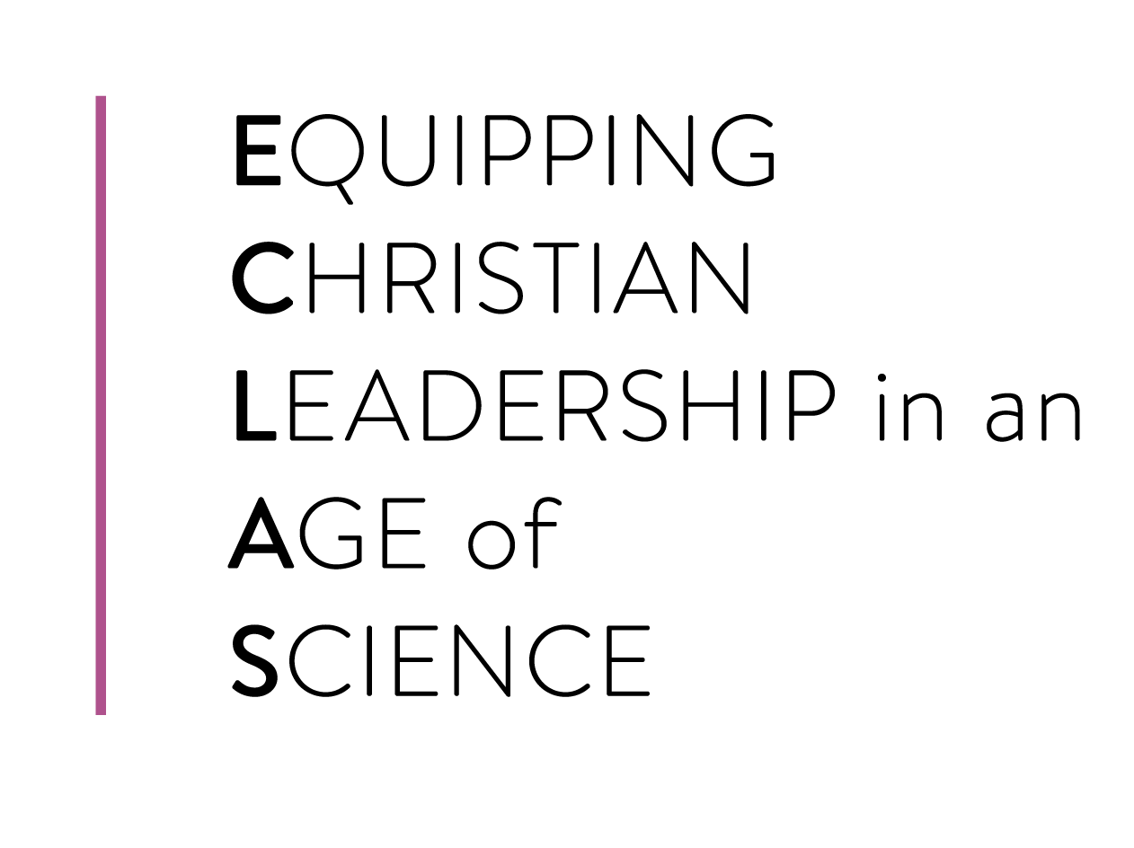  CONVENOR | Funded by the  John Templeton Foundation  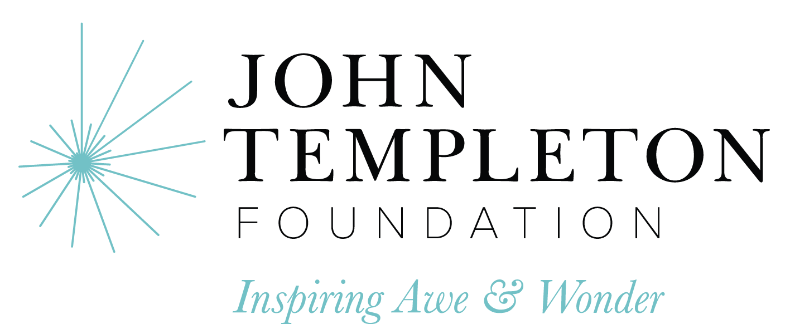  PARTNERS
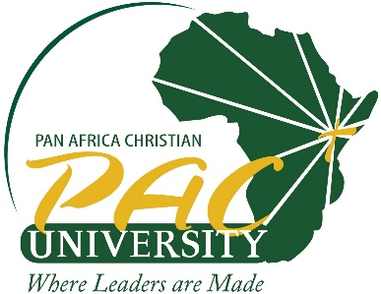
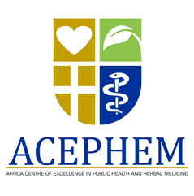

FOR FURTHER INQUIRIES & ABSTRACT SUBMISSIONS
eclas@spu.ac.ke
☎ +254 728 669 000
🌐 https://eclasafrica.org/conferences
ECLAS Africa Hub • St. Paul’s University, Limuru, Kenya • www.spu.ac.ke
Kamuzu University of Health Sciences, Blantyre, Malawi • www.kuhes.ac.mw

All rights reserved: ECLAS Africa Hub 2026 Conference Convener

